Exit Pass- Using Trigonometry to find side lengths and angles in right-angled triangles
20 mins /17
1. | MULTIPLE CHOICE  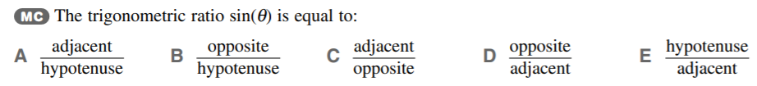 | 1 mark
2. | Determine the size of the unknown angle, θ correct to 2 decimal places.  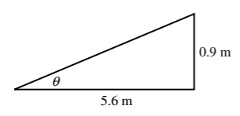 | 3 marks
3. | 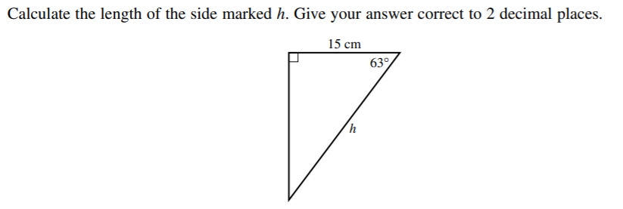 | 3 marks
4. | 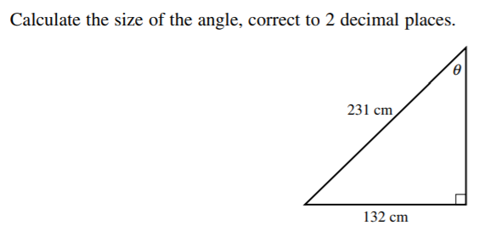 | 3 marks
5. |  | 3 marks
6. | 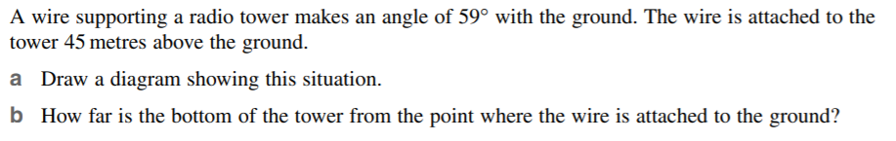 | 1 mark  3 marks

